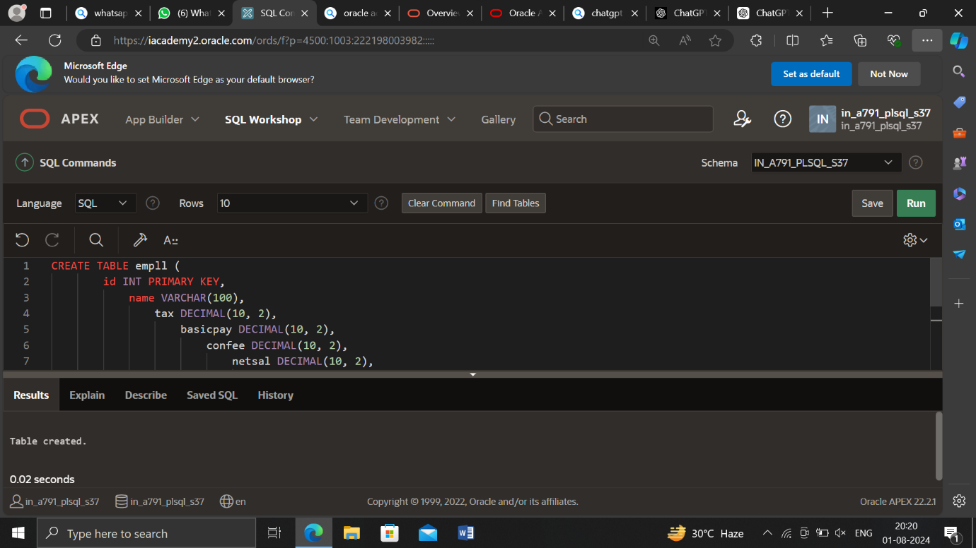

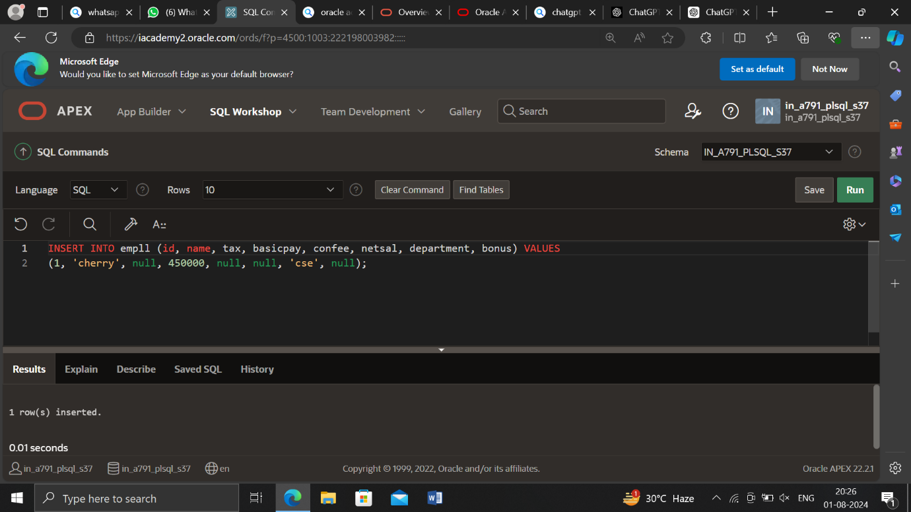

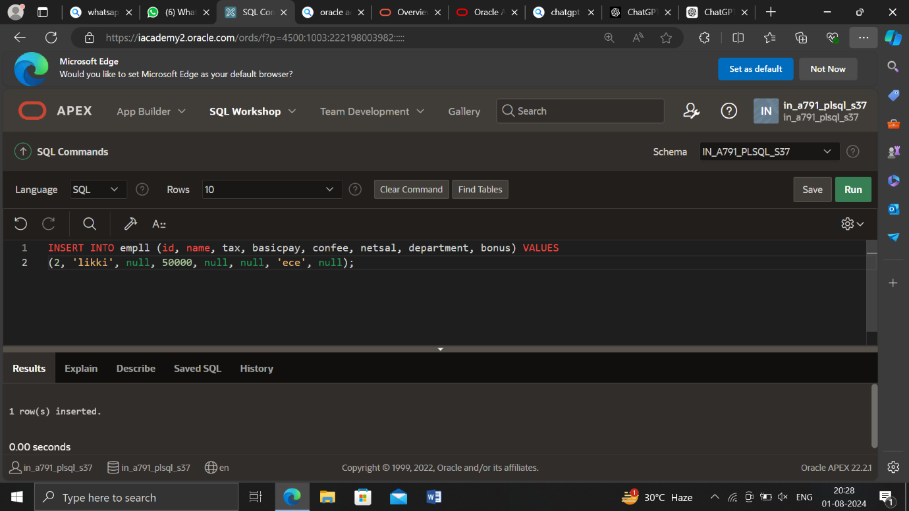

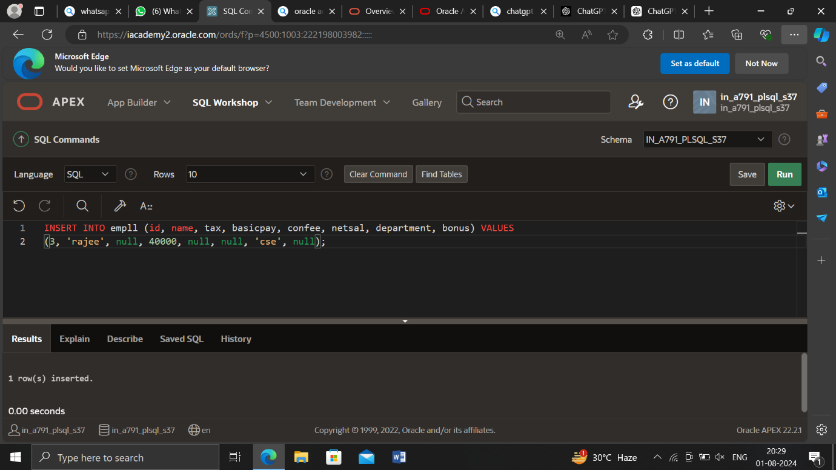

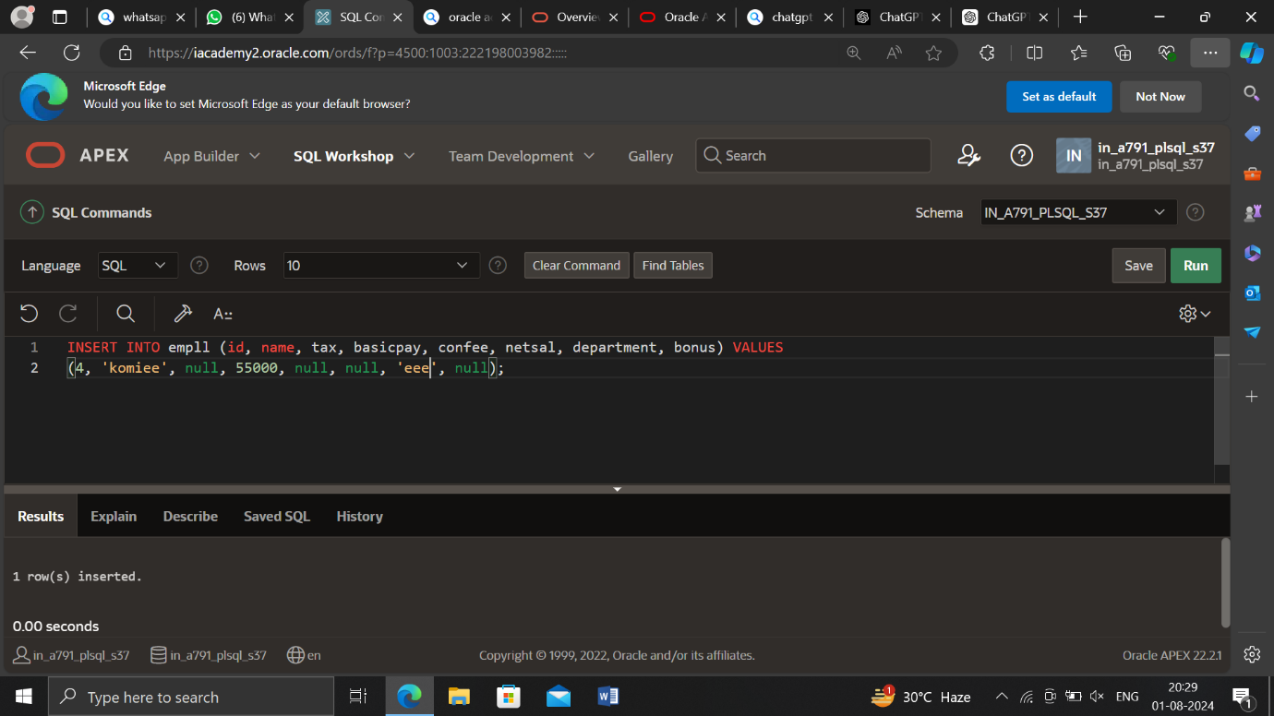

Tax updation:

DECLARE

CURSOR cempl IS SELECT * FROM employee;

emp_record cempl%ROWTYPE;

BEGIN

OPEN cempl;

LOOP

FETCH cempl INTO emp_record;

EXIT WHEN cempl%NOTFOUND;

IF emp_record.basicpay = 30000 THEN

UPDATE employee

SET tax = 0.1 * emp_record.basicpay

WHERE id = emp_record.id;

ELSIF emp_record.basicpay > 30000 THEN

UPDATE employee

SET tax = 0.2 * emp_record.basicpay

WHERE id = emp_record.id;

END IF;

END LOOP;

CLOSE cempl;

END;

/

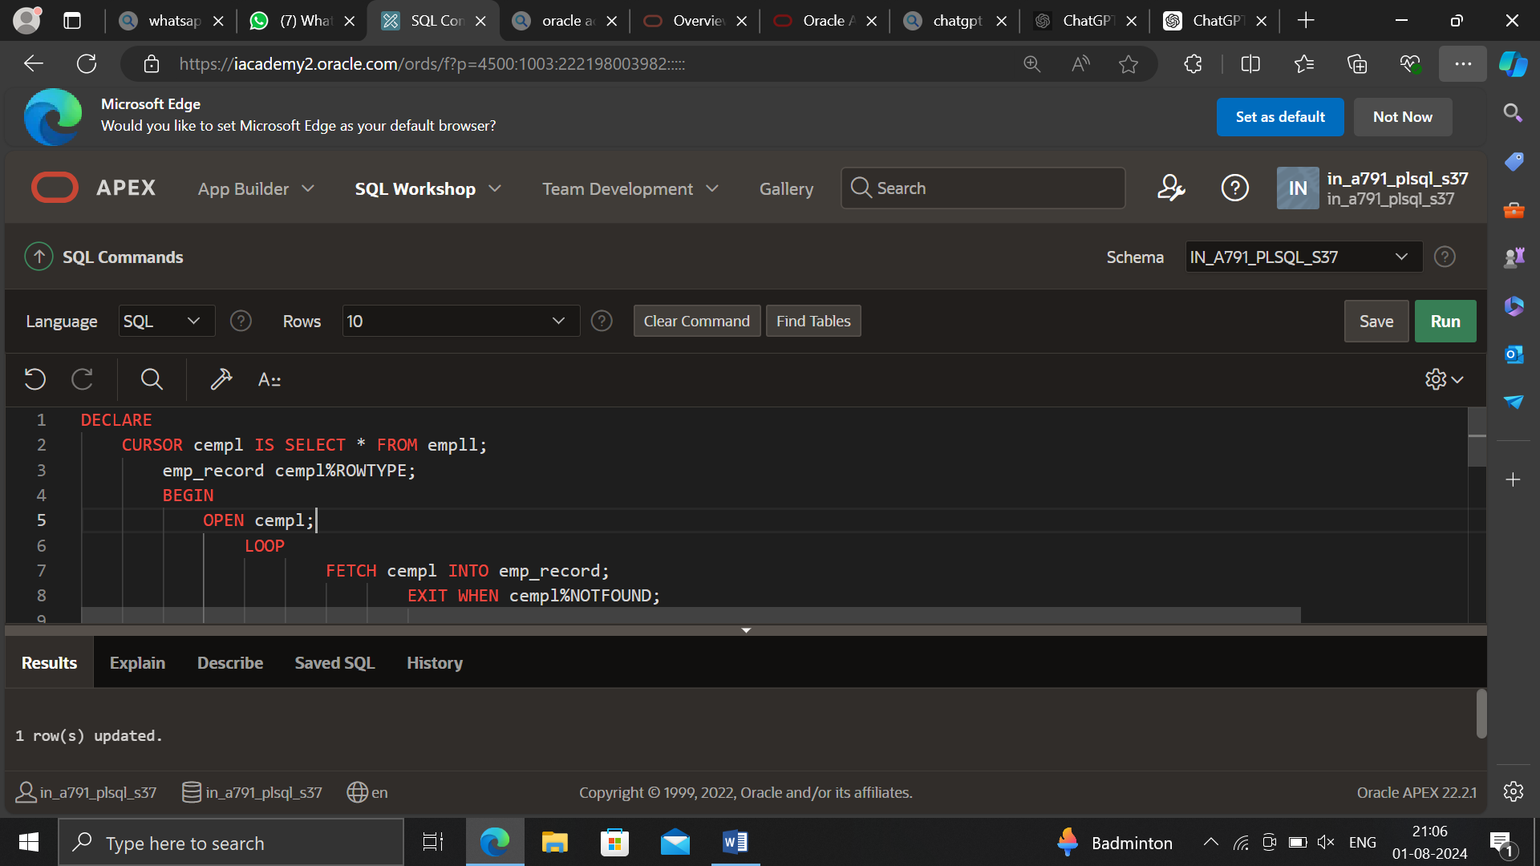

Confee updation:

DECLARE

CURSOR cempl IS SELECT * FROM employee;

emp_record cempl%ROWTYPE;

BEGIN

OPEN cempl;

LOOP

FETCH cempl INTO emp_record;

EXIT WHEN cempl%NOTFOUND;

-- Update confee based on basicpay conditions

IF emp_record.basicpay = 30000 THEN

UPDATE employee

SET confee = 0.05 * emp_record.basicpay

WHERE id = emp_record.id;

ELSIF emp_record.basicpay > 30000 THEN

UPDATE employee

SET confee = 0.08 * emp_record.basicpay

WHERE id = emp_record.id;

ELSE

UPDATE employee

SET confee = 0.03 * emp_record.basicpay

WHERE id = emp_record.id;

END IF;

END LOOP;

CLOSE cempl;

END;

/

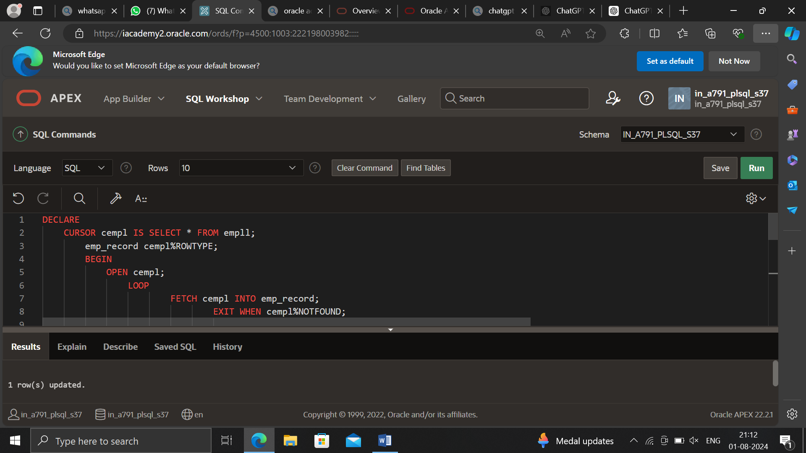

Bonus updation:

DECLARE

CURSOR cempl_cse IS SELECT * FROM employee WHERE department = 'cse';

emp_record_cse cempl_cse%ROWTYPE;

CURSOR cempl_ece IS SELECT * FROM employee WHERE department = 'ece';

emp_record_ece cempl_ece%ROWTYPE;

CURSOR cempl_eee IS SELECT * FROM employee WHERE department = 'eee';

emp_record_eee cempl_eee%ROWTYPE;

BEGIN

-- Update bonus for 'cse' department employees

OPEN cempl_cse;

LOOP

FETCH cempl_cse INTO emp_record_cse;

EXIT WHEN cempl_cse%NOTFOUND;

UPDATE employee

SET bonus = 0.25 * emp_record_cse.basicpay

WHERE id = emp_record_cse.id;

END LOOP;

CLOSE cempl_cse;

-- Update bonus for 'ece' department employees

OPEN cempl_ece;

LOOP

FETCH cempl_ece INTO emp_record_ece;

EXIT WHEN cempl_ece%NOTFOUND;

UPDATE employee

SET bonus = 0.20 * emp_record_ece.basicpay

WHERE id = emp_record_ece.id;

END LOOP;

CLOSE cempl_ece;

-- Update bonus for 'eee' department employees

OPEN cempl_eee;

LOOP

FETCH cempl_eee INTO emp_record_eee;

EXIT WHEN cempl_eee%NOTFOUND;

UPDATE employee

SET bonus = 0.10 * emp_record_eee.basicpay

WHERE id = emp_record_eee.id;

END LOOP;

CLOSE cempl_eee;

END;

/

